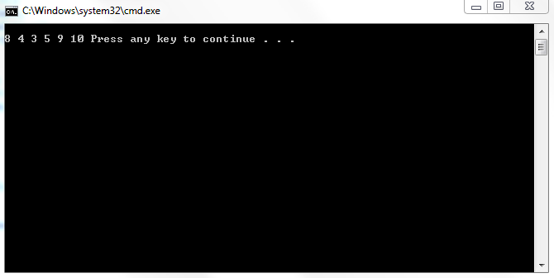
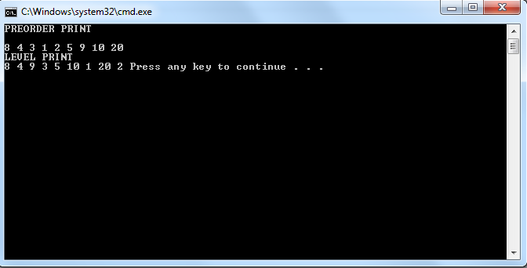
POSTLAB:
#include<iostream>
#include <queue>
using namespace std;
class TreeNode {

public:

int value;
TreeNode* left;
TreeNode* right;
};

class TreeType {
TreeNode* root;
public:
TreeType(){root =NULL;};
void insertItem(int value);
void bstinsert(int val);
void print();
void print_preorder(TreeNode * r);
void level(TreeNode * r);
void bst(TreeType *&Tree);
};
void TreeType::bstinsert(int val)
{
TreeNode *tree = root;
TreeNode *temp= new TreeNode;
temp->left = NULL;
temp->right = NULL;
temp->value = val;
if(tree == NULL)
root=tree=temp;
else{
while((tree->left != NULL && val<tree->value)||(tree->right !=NULL && val>tree->value))
{
if(tree->value>val)
tree=tree->left;
else if(tree->value<val)
tree=tree->right;
}
if(tree->value>val)
tree->left=temp;
else if(tree->value<val)
tree->right=temp;
}
}
void TreeType::bst(TreeType *&Tree)
{
queue<TreeNode*> q;
if(root == NULL)
return;
else
{
q.push(root);
while(!q.empty())
{
TreeNode *temp = q.front();
q.pop();
Tree->bstinsert(temp->value);
if(temp->left !=NULL)
q.push(temp->left);
if(temp->right !=NULL)
q.push(temp->right);

}
}
}
void TreeType::insertItem(int val)
{
TreeNode *tree = root;
TreeNode *temp= new TreeNode;
temp->left = NULL;
temp->right = NULL;
temp->value = val;
if(tree == NULL)
root=tree=temp;
else{
bool done=false;
while(!done)
{
if(tree->left ==NULL)
{
tree->left=temp;
done =true;
}
else if(tree->right == NULL)
{
tree->right=temp;
done =true;
}
else
tree=tree->left;
}
}
}
void TreeType::print()
{
cout<<endl;
print_preorder(root);
cout<<endl;
cout<<"LEVEL PRINT\n";
level(root);

}
void TreeType::print_preorder(TreeNode *r)
{
if(r == NULL)
return;
else
{
cout << r->value<<" ";
print_preorder(r->left);
print_preorder(r->right);
}

}
void TreeType::level(TreeNode *r)
{
queue<TreeNode*> q;
if(r == NULL)
return;
else
{
q.push(r);
while(!q.empty())
{
TreeNode *temp = q.front();
cout<<temp->value<<" ";
q.pop();
if(temp->left !=NULL)
q.push(temp->left);
if(temp->right !=NULL)
q.push(temp->right);

}
}

}
void main() {
TreeType* MyTree = new TreeType;
TreeType* MyTree2 = new TreeType;
cout<<"BINARY TREE\n";
MyTree->insertItem(8);
MyTree->insertItem(9);
MyTree->insertItem(4);
MyTree->insertItem(10);
MyTree->insertItem(3);
MyTree->insertItem(5);
MyTree->insertItem(20);
cout<<"PREORDER PRINT\n";
MyTree->print();
MyTree->bst(MyTree2);
cout<<"\n\nBINARY SEARCH TREE\n";
cout<<"\nPREORDER PRINT\n";
MyTree2->print();
system("pause");
}
